16 Question 4(a):
In long Transmission Line or cable, the receiving end voltage is greater than the sending end voltage during light load or no-load operation. Under No-load or light load condition, the capacitance associated with the line generate more reactive power than the reactive power which is absorbed, hence Vr > Vs. This effect is called is known as Ferranti effect.
Occurs in 50kms to 240kms and above 240kms lines.

How to reduce Ferranti effect:
Ferranti effect can be reduced by installing shunt compensation devices at receiving end. The compensation device is a shunt reactor which is connected in parallel with the transmission line. It reduces the voltage level by absorbing the reactive power.
Running the transmission line with higher load. I.e if you have two line both carries 5 % load in each side means, we can switch of the one transmission line and the remaining load can be diverted in to another one.

Terminology:

EHV: 300 kV to 765 kV are known as Extra High Voltages (EHV).

UHV: The voltages which are 765 kV are termed as Ultra High Voltage (UHV).

16|5|a
These are very severe faults and occur infrequently in the power systems. These are also called as balanced faults and are of two types namely line to line to line to g
round (L-L-L-G) and line to line to line (L-L-L).
Only 2-5 percent of system faults are s

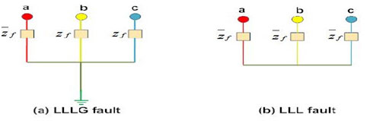

Only 2-5 percent of system faults are symmetrical faults. If these faults occur, system remains balanced but results in severe damage to the electrical power system equipment's. Above figure shows two types of three phase symmetrical faults. Analysis of these faults is easy and usually carried by per phase basis. Three phase fault analysis or information is required for selecting set-phase relays, rupturing capacity of the circuit breakers and rating of the protective switch-gear.

16 Question 5(b)
Short circuit currents can be limited by using series inductor in lines. It will reduce the short circuit
currents.

5(c)

Feeder
Definition: A three phase distribution line circuit used as a source to other three phase and single phase circuits.
Usually short circuits occur on feeders therefore, feeder reactors are very important. In the absence of feeder reactors, if a fault occurs on the nearest generating station, the bus bar voltage will be reduced to zero and the connected generators will lose their synchronism.
Advantages:
The voltage drop across a reactor during faulty conditions will not affect the voltage of bus bar, therefore, there are less chances of losing synchronism.
A fault on a feeder will not affect any other feeder.
Disadvantages:
Every feeder needs a reactor hence the number or reactors increases.
If the number of generators increases, then the size of the reactor should also be increased.
During normal operation, full load current passes through the reactor which causes continuous power loss.

16 Question 7b
In unsymmetrical fault calculations, each part of equipment will have three values of impedance one corresponding to each sequence current. This is called sequence network.

15 Question 4a
Load flow studies are one of the most important aspects of power system planning and operation. The load flow gives us the sinusoidal steady state of the entire system - voltages, real and reactive power generated and absorbed and line losses.
Significance of load flow analysis in power system-
- We can obtain the voltage magnitudes and angles at each bus in the steady state. magnitudes of the bus voltages are required to be held within a specified limit. Using the voltage magnitudes and their angles, the real and reactive power flow through each line can be computed.
- Also based on the difference between power flow in the sending and receiving ends, the losses in a particular line can also be computed.
- From the line flow we can also determine the over and under load conditions.
- The load flow study of a power system is essential to decide the best operation of existing system and for planning the future expansion of the system.
- It helps in designing a new power system network.
- It helps in System loss minimization and transformer tap setting for economic operation.

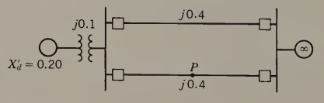
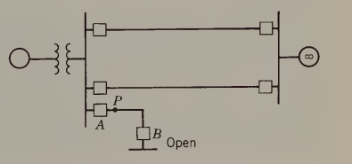
Stability:
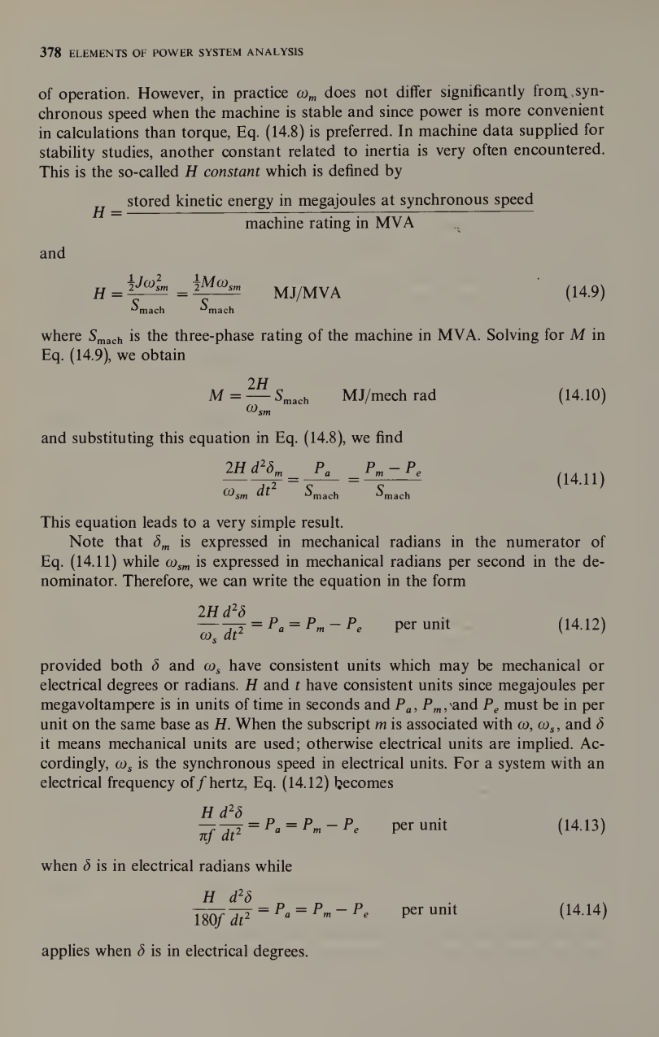
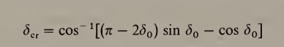
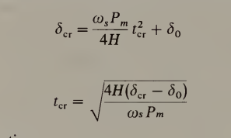
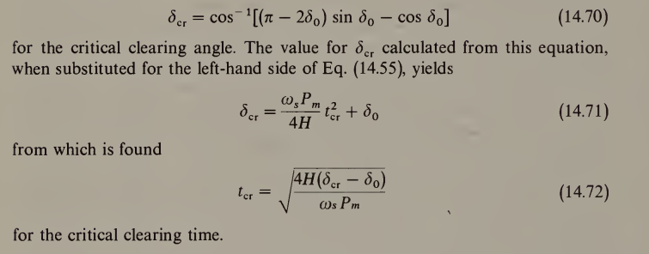
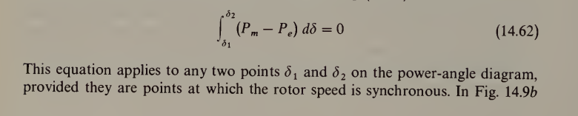
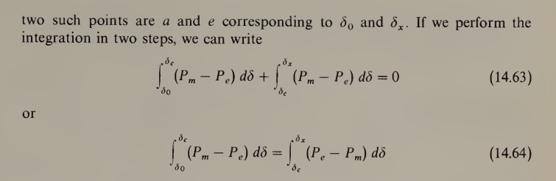

Inductance:
Transmission line
Fault analysis
Per unit system
Load flow analysis

